**MARKET SEGMENTATION**

Team Kalyaan

Kalyaan Rao

Nimesh Patel

Ankit Kumar

Ganesh Srinivas

8th August 2022

Market Segmentation is essentially the strategy of breaking up your target market into reachable groups. In order to better understand the target audience, market segmentation divides the market into subsets based on demographics, requirements, priorities, shared interests, and other psychological or behavioural factors.

We can use this targeting in our product, sales, and marketing efforts by analysing our market segments. By influencing how we can develop product offers for various segments such as males vs females, high income vs low income, market segmentation can empower the product development cycles.

The benefits of market segmentation –

Companies who properly segment their market enjoy significant advantages. According to a study by a Bain & Company, 81% of the executives found that market segmentation was crucial for growing profits. Bain also found out that organisations with great market segmentation strategies enjoyed a 10% higher profit than companies whose segmentation wasn’t as effective over a 5-year period.

Other benefits include -

* **Stronger marketing messages** – You no longer have to be generic and vague. You can speak directly to a specific group of people suiting to their desires and specific needs and characteristics.
* **Developing effective marketing strategies** – Knowing your target audience gives you a head start about what methods, tactics and solutions they are most responsive to.
* **Better response rates and lower acquisition rates –** Thesewill result from creating your marketing communications both in ad messaging and advanced targeting in on digital platforms like Facebook and Google using your segmentation.
* **Identifying niche markets –** Segmentation can uncover not only undeserved markets, but also new ways of serving existing markets – opportunities that can be used to grow the brand.
* **Enhanced Profits –** Different customers have different disposable incomes; prices can be set according to how much they are willing to spend. With this we can factor whether we are over selling or under selling our products.

Types of market segmentation –

With segmentation and targeting, you want to understand how your market will respond in a given situation, like purchasing your products. In many cases, a predictive model may be incorporated into the study so that we can group individuals within identified segments based on specific answers to survey questions.

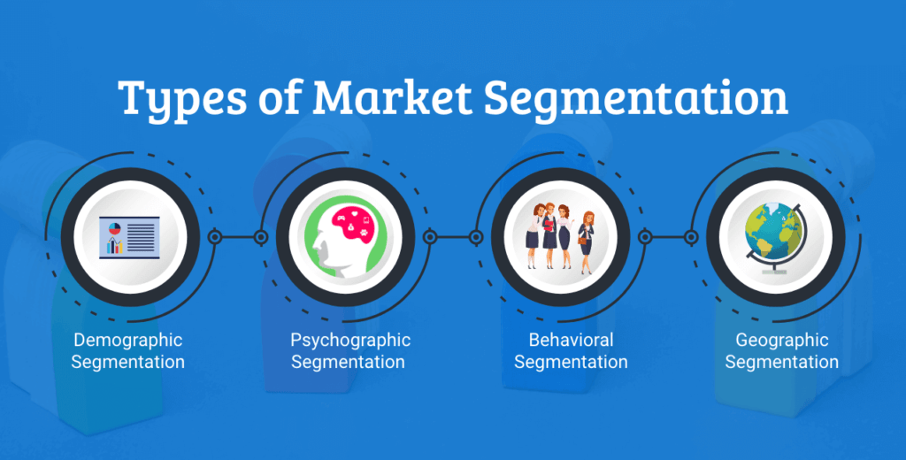

* **Demographic Segmentation** – Demographic segmentation sorts a market by age, education, income, occupation and gender. Demographic is one of the most commonly used and simplest type of segmentation used because the products and their services we buy, how we use those products and how much we are willing to spend on them is most often based on demographic factors.
* **Geographic Segmentation –** Geographic segmentation can be a subset of demographic segmentation, although it can also be a type of segmentation in itself. It creates a type of segmentation based on geographical boundaries. Potential customers have specific need, interests that differ according to their geographies, understanding the climates and geographical preferences can help determine where to sell and advertise as well as where to expand your business.
* **Behavioural Segmentation –** Behavioural segmentation divides markets by behaviours and decision-making patterns such as purchase, consumption, lifestyle and usage. For instance, younger buyers may tend to purchase bottled body wash, while older customers lean towards the conventional soap bars. Segmenting markets based on purchase behaviour enables marketers to develop a more targeted approach because you can focus on what they know and therefore more likely to buy.
* **Psychographic Segmentation -** Psychographic segmentation considers the psychological aspects of consumer behaviour dividing marketing segments according to the lifestyle, personality traits, values, opinions and interests of consumers. Large markets like the fitness markets use psychographic segmentation when they sort their customers into categories of people who care about their way of living and health.

Steps of Segmentation –

Identifying the target market starts with segmentation. Once you understand your customers and are able to segment the market, you can identify the target market with the most potential. There is a process of segmenting the market and then selecting and reaching the target segments. The process has five steps as shown in the figure below –

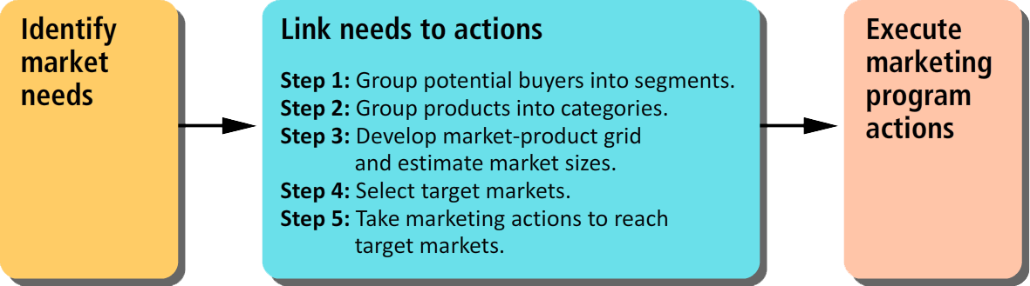

Step 1: There are five main criteria to use when forming the segments –

* **Potential for increased profit** – Segmentation is costly. Business only apply segmentation only if it will lead to higher profits. If there is no chance of increasing profits, then there is no need of segmentation.
* **Similarity of needs of potential buyers within a segment** – Potential consumers who are in the same segment must share similar needs and wants. Businesses take marketing actions towards each segment and they expect to get the same reaction from consumers who are in the same segment.
* **Difference of needs of buyers among segments** – Potential customers who are in different segments must have different needs and wants. If they share similar needs and wants, they should be in the same segments. Different segments need different marketing strategies, which means greater costs. It helps to lower the cost if the firm combines the segments that are not significantly different from each other.
* **Potential of a marketing action to reach a segment** – Reaching a segment requires effective marketing actions. If the actions are very complicated or impossible to take then there is no point in segmentation.
* **Simplicity and cost of assigning potential buyers to segments** – As mentioned earlier, segmentation is costly. It requires research to identify specific needs of potential buyers. If the research shows that the needs are very diverse and that trying to segment will lead to so many micro segments that will increase the cost.

Step 2: Group products to be sold into categories –

Businesses pay close attention to the differences in the needs of consumers in each segment. In order to address the needs in the best way possible, businesses create differentiated products. These products could be different based on the features of the product, pricing, distribution, etc. As you have learned, companies have full control over the marketing mix elements (4Ps) which allows them to create different mixes of the 4Ps to create differentiated products.

Step 3: Develop a market product grid and estimate size of markets –

You have seen an example of a market-product grid from Sleep Country. Below is an additional example from a fast-food restaurant that is located next to an urban university. We label the market segments in the horizontal rows and products in the vertical columns as shown in the table below. The market sizes are estimates from zero to three. Zero means no potential. One represents small potential. Two represents medium size potential. Three shows the most potential.

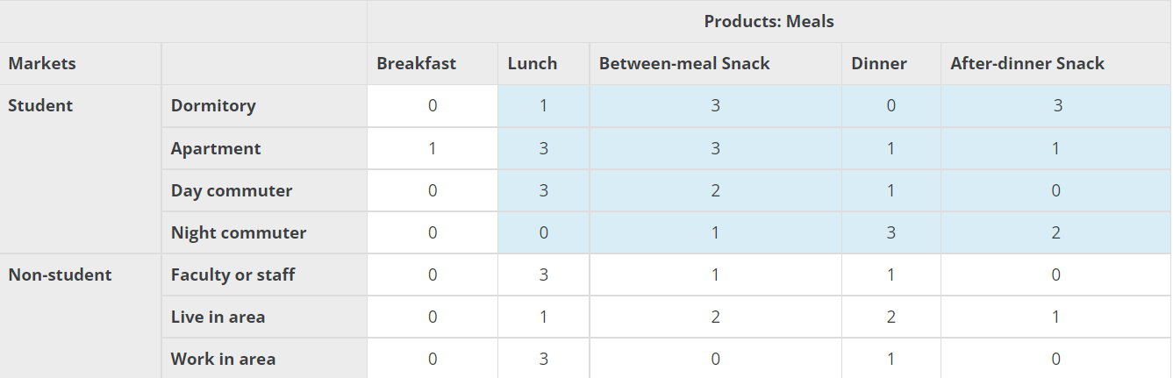

Step 4: Select target markets –

Once you develop a market-product grid, it is fairly easy to identify the target market from the grid based on the highest market size estimates.

The grid is the tool to use when selecting a target market

Step 5: Take marketing actions to reach the target markets –

Identifying target markets makes it possible to take actions towards the segments we include in the target market. Based on the characteristics of each segment, marketers decide on the best tools to reach out to these segments.

**Machine Learning and Segmentation** –

Machine learning, a class of artificial intelligence, can investigate data sets of similar customers and interpret the most beneficial and most inadequate performing customer segments.

One of the most important steps is to collect and analyse the data required for the segmentation. It involves discovering different patterns and biases inside the dataset.

**Step 1:** **Pre-Processing and Data Cleaning –**

Data cleaning is the process of preparing data for analysis by removing or modifying data that is incorrect, incomplete, irrelevant, duplicated, or improperly formatted.

Data Cleaning involves –

* Fixing spelling and syntax errors
* Standardizing datasets
* Correcting mistakes such as empty fields
* Identifying duplicate data points.

Some steps that can be taken to properly prepare the data are –

**Removing Duplicate Observations** - Duplicate data most often occurs during the data collection process. This typically happens when you combine data from multiple places, or receive data from clients or multiple departments. You want to remove any instances where duplicate data exists.

You also want to remove any irrelevant observations from your dataset. This is where you data doesn’t fit into the specific problem you’re trying to analyze. This will help you make your analysis more efficient.

**Filter Out wanted Outliers** - Outliers are unusual values in your dataset. They’re significantly different from other data point and can distort your analysis and violate assumptions. Removing them is a subjective practice and depends on what you’re trying to analyse. Generally speaking, removing unwanted outliers will help improve the performance of the data you’re working with. Outliers can also be removed with the help of data visualisation by using different scatter plots, histograms and boxplots. Some of the statistical methods for outlier detection and removal include the Chi-Squared test, Z-test, t-test and the use of inter quartile ranges.

**Fix Missing Data** - Make sure that any data that’s missing is filled in. A lot of algorithms won’t accept missing values. You may either drop the missing values using the dropna()and fillna() values.

**Feature Scaling** – The final step of data pre-processing is to apply the scaling feature. Feature scaling is a technique to standardise the independent features present in the data in a fixed range. It is performed during data pre-processing.

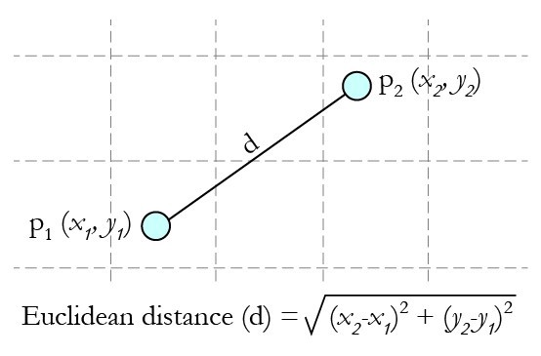

Most of the times, a dataset may contain features highly varying in magnitudes, ranges and units. Since most of the machine learning algorithms use Euclidean distance for computation, problems may arise. Some of the ways for feature scaling are –

**Standardisation** –

This is one of the most use types of scalars in data pre-processing. This is known as z-score. This re distribute the data in such a way that mean (μ) = 0 and standard deviation (σ) =1. Here is the below formula for calculation.

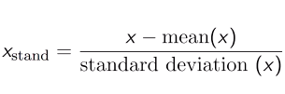

**Normalisation** –

Normalization scales the feature between 0.0 & 1.0, retaining their proportional range to each other

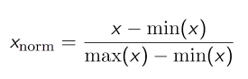

**Step 2:** **Extracting Segments –**

Clustering can be used to extract the various market segments present in the dataset. Some of the methods based on clusters are –

**Centroid Based Clusters** - **Centroid-based clustering** organizes the data into non-hierarchical clusters, in contrast to hierarchical clustering defined below. k-means is the most widely-used centroid-based clustering algorithm. Centroid-based algorithms are efficient but sensitive to initial conditions and outliers. This course focuses on k-means because it is an efficient, effective, and simple clustering algorithm.

K-means clustering is the most commonly used clustering algorithm. It's a centroid-based algorithm and the simplest unsupervised learning algorithm.

This algorithm tries to minimize the variance of data points within a cluster. It's also how most people are introduced to unsupervised machine learning.

K-means is best used on smaller data sets because it iterates over all of the data points. That means it'll take more time to classify data points if there are a large amount of them in the data set.

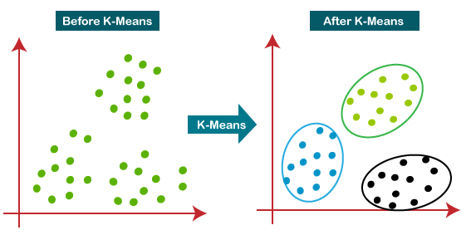

**Hierarchical Based Clustering** - Hierarchical-based clustering is typically used on hierarchical data, like you would get from a company database or taxonomies. It builds a tree of clusters so everything is organized from the top-down.

This is more restrictive than the other clustering types, but it's perfect for specific kinds of data sets.

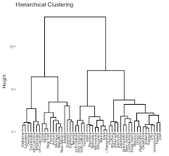

**Density Based Clustering** - In density-based clustering, data is grouped by areas of high concentrations of data points surrounded by areas of low concentrations of data points. Basically, the algorithm finds the places that are dense with data points and calls those clusters.

The great thing about this is that the clusters can be any shape. You aren't constrained to expected conditions.

The clustering algorithms under this type don't try to assign outliers to clusters, so they get ignored.

DBSCAN stands for density-based spatial clustering of applications with noise. It's a density-based clustering algorithm, unlike k-means.

This is a good algorithm for finding outliners in a data set. It finds arbitrarily shaped clusters based on the density of data points in different regions. It separates regions by areas of low-density so that it can detect outliers between the high-density clusters.

This algorithm is better than k-means when it comes to working with oddly shaped data.

DBSCAN uses two parameters to determine how clusters are defined: minPts (the minimum number of data points that need to be clustered together for an area to be considered high-density) and eps (the distance used to determine if a data point is in the same area as other data points).

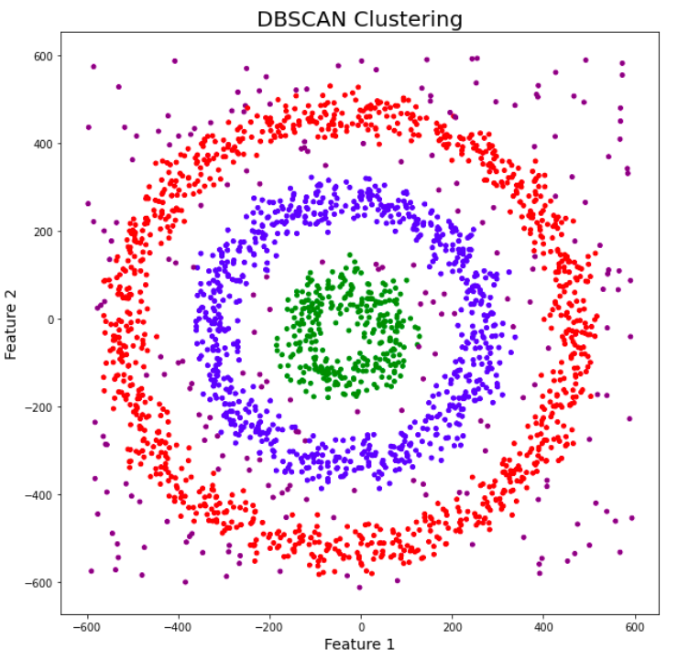

**Finite Mixtures of Regressions** - Finite mixtures of distributions are similar to distance-based clustering methods

and – in many cases – result in similar solutions. Compared to hierarchical or

partitioning clustering methods, mixture models sometimes produce more useful,

and sometimes less useful solutions.

**Step 3:** **Profiling Segments –**

**Identifying Key Characteristics of Market Segments –**

The aim of the profiling step is to get to know the market segments resulting from

the extraction steps. Profiling is only required when data-driven market segmentation

is used. For common sense segmentation, the profiles of the segments are predefined. The situation is quite different in the case of data-driven segmentation: users of

the segmentation solution may have decided to extract segments on the basis of

benefits sought by consumers. Yet – until after the data has been analysed – the

defining characteristics of the resulting market segments are unknown. Identifying

these defining characteristics of market segments with respect to the segmentation

variables is the aim of profiling. Profiling consists of characterising the market

segments individually, but also in comparison to the other market segments. If

winter tourists in Austria are asked about their vacation activities, most state they

are going alpine skiing. Alpine skiing may characterise a segment, but alpine skiing

may not differentiate a segment from other market segments.

At the profiling stage, we inspect a number of alternative market segmentation

solutions. This is particularly important if no natural segments exist in the data,

and either a reproducible or a constructive market segmentation approach has to be

taken. Good profiling is the basis for correct interpretation of the resulting segments.

**Assessing Segment Separation** –

A good way to understand the defining characteristics of each segment is to produce

a segment profile plot. The segment profile plot shows – for all segmentation

variables – how each market segment differs from the overall sample.

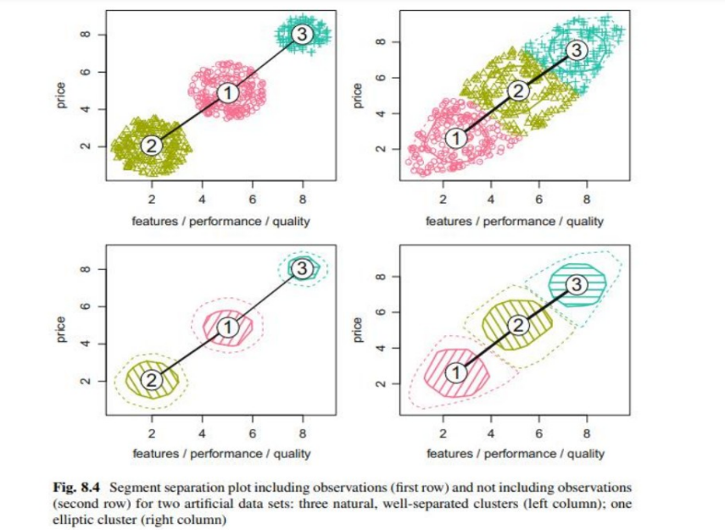

Segment Separation using Visualisation –

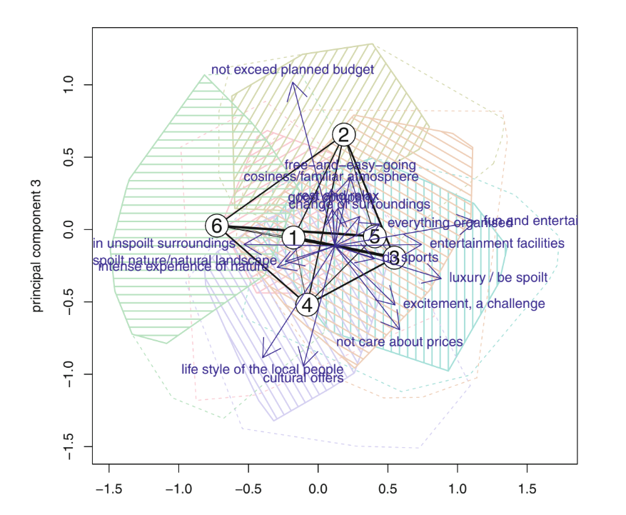

Each segment separation plot only visualises one possible projection. So, for

example, the fact that segments 1 and 5 in this particular projection overlap with

other segments do not mean that these segments overlap in all projections.

However, the fact that segments 6 and 3 are well-separated in this projection does

allow the conclusion – based on this single projection only – that they represent

distinctly different tourists in terms of the travel motives.

**Step 4: Describing Segments –**

Using Visualisations to describe market segments - A wide range of charts exist for the visualisation of differences in descriptor

variables. Here, we discuss two basic approaches suitable for nominal and ordinal

descriptor variables (such as gender, level of education, country of origin), or metric

descriptor variables (such as age, number of nights at the tourist destinations, money

spent on accommodation).

Using graphical statistics to describe market segments has two key advantages:

it simplifies the interpretation of results for both the data analyst and the user, and

integrates information on the statistical significance of differences, thus avoiding the

over-interpretation of insignificant differences.

Using Descriptor Variables - When describing differences between market segments in one single nominal or ordinal descriptor variable, the basis for all visualisations and statistical tests is a cross-tabulation of segment membership with the descriptor variable.

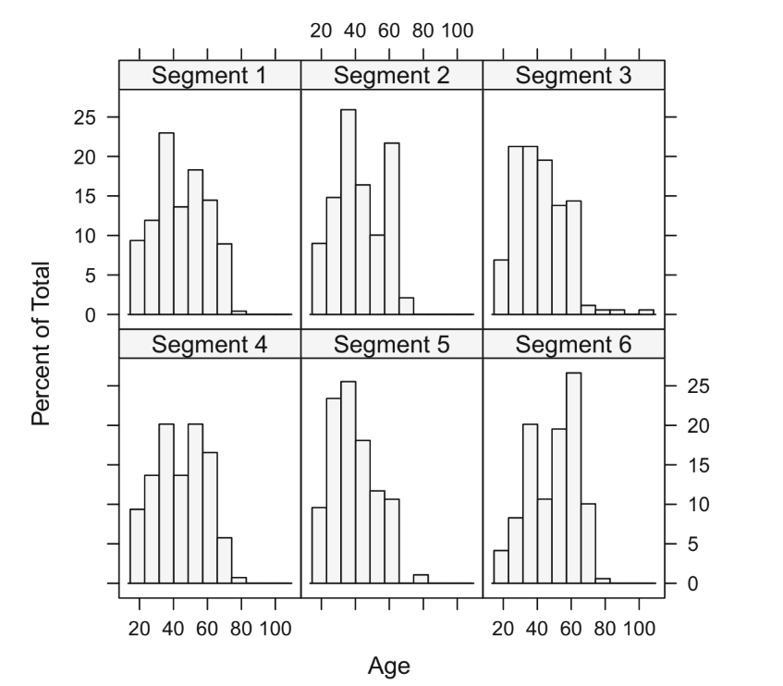

The notches in this version of the parallel box-and-whisker plot correspond to

95% confidence intervals for the medians. If the notches for different segments do

not overlap, a formal statistical test will usually result in a significant difference. We

can conclude from the inspection of the plot in Fig above alone, therefore, that there

is a significant difference in moral obligation to protect the environment between

members of segment 3 and members of segment.

Testing for segment differences in descriptor variables - Simple statistical tests can be used to formally test for differences in descriptor

variables across market segments. The simplest way to test for differences is to

run a series of independent tests for each variable of interest. The outcome of the

segment extraction step is segment membership, the assignment of each consumer

to one market segment. Segment membership can be treated like any other nominal

variable. It represents a nominal summary statistic of the segmentation variables.

Therefore, any test for association between a nominal variable and another variable

is suitable. The appropriate test for independence between columns and rows

of a table is the χ2-test.

A chi-square test is a statistical test used to compare observed results with expected results. The purpose of this test is to determine if a difference between observed data and expected data is due to chance, or if it is due to a relationship between the variables you are studying. Therefore, a chi-square test is an excellent choice to help us better understand and interpret the relationship between our two categorical variables.

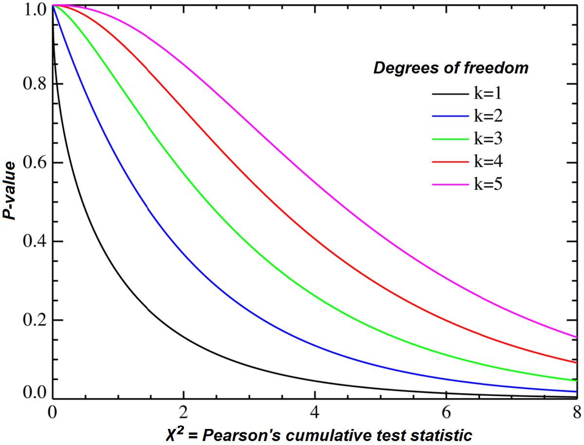

**Step 5: Selecting the target segments –**

Which of the many potential market segments will be chosen for targeting is now the major question. Marketing segmentation is a clever marketing device. It takes time and effort to choose one or more target segments. It is a long-term choice that will have a substantial impact on organisation’s performance moving forward. This is the time where all the fun and game translate into serious business talk that may have a long-term effect on the future of the business.

Following this, it is necessary to assess the remaining segments’ attractiveness and relative organisational competitiveness. In other words, the segmentation team must pose a number of queries that can be divided into two main groups –

* Which market category would the company chose to focus on? What market would the organisation like to invest in?
* Which of the businesses selling the same item would each of the segments prefer to purchase from? How likely is it that our company will be selected? What is the likelihood that each part would agree to join us? The selection regarding the target segment is based on the answers to these two questions.

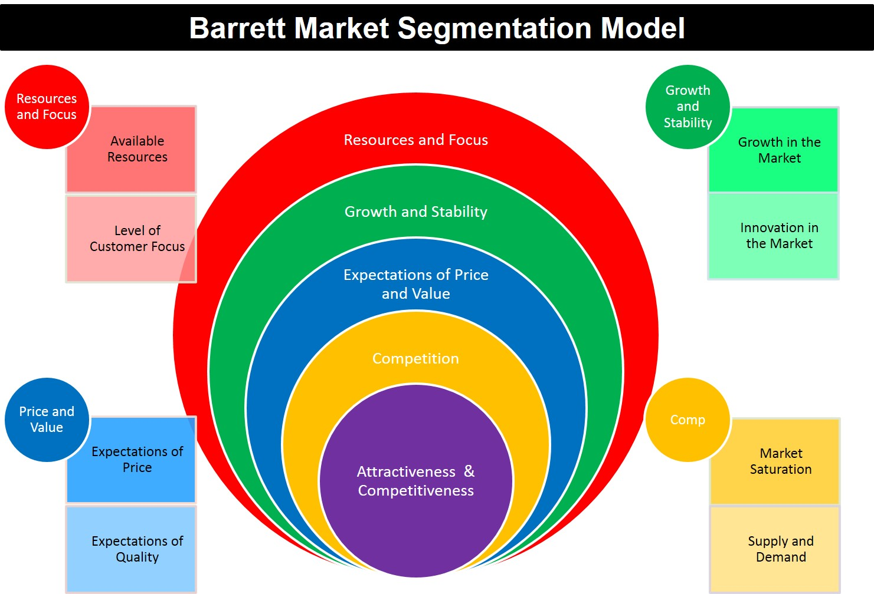

**Step 6: Customising the market mix –**

The marketing mix refers to the various elements of your company’s offerings in the market. It is a varied ‘mix of ingredients’ used by the business to achieve it’s objectives by marketing it’s products or services effectively to a particular customer group.

The marketing mix also referred to as the 4P’s, is comprised of four main pieces – Product, Price, Promotion and Place. The 4P’s describe what marketers can control and are the most critical elements when building your marketing strategy.

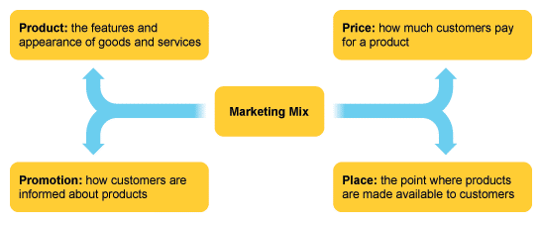

Market segmentation cannot be used as a stand-alone marketing tactic. Instead, it compliments the other components of strategic marketing, most importantly, positioning and rivalry. In fact, segmentation, is frequently used as part of what is known as the segmentation targeting positioning. The segmentation targeting positioning assumes an approach where the events happen in order. Market Segmentation, which involves extracting, describing, and characterising market segments, is the first step in the process.

Last but not the least, positioning (the actions that the organisations can take to ensure that their products are viewed as significantly different from competitor’s offerings and in line with segment needs) involves assessing segments and choosing a target segment. Although the segmentation-targeting-positioning process is sequential, it's crucial to not stick to it too rigidly. From the segmentation to the targeting process, it could be required to go back and forth before being in a position to make a long-term commitment to one or a small number of segments.

**Github Links –**

* <https://github.com/AnkitL7/McDonald-CaseStudy>
* <https://github.com/kalyaannnn/McDonald-s-CaseStudy>
* <https://github.com/ganeshasrinivasd/McD_Market_Segmentation/tree/main>
* <https://github.com/nimesh8491/mcdonald.git>